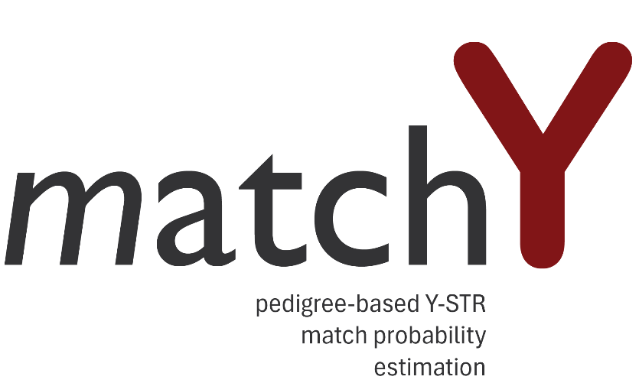

User manual GUI v1.0

Content
How to use matchY 2
Setting up your calculation: 2
The marker set file: 2
The pedigree file: 3
The haplotype files: 3
Pedigree builder 3
Setting up the simulation 4
Suspect: 4
Excluded individuals: 4
Set simulation parameters: 4

How to use the MatchY GUI
Open the MatchY software via your local browser (default: localhost:8501). Check the installation manual for details, or ask your system administrator.

Marker sets
Before you start setting up your simulation, it is best to first start by setting up your marker sets. Go to Marker sets in the main menu.
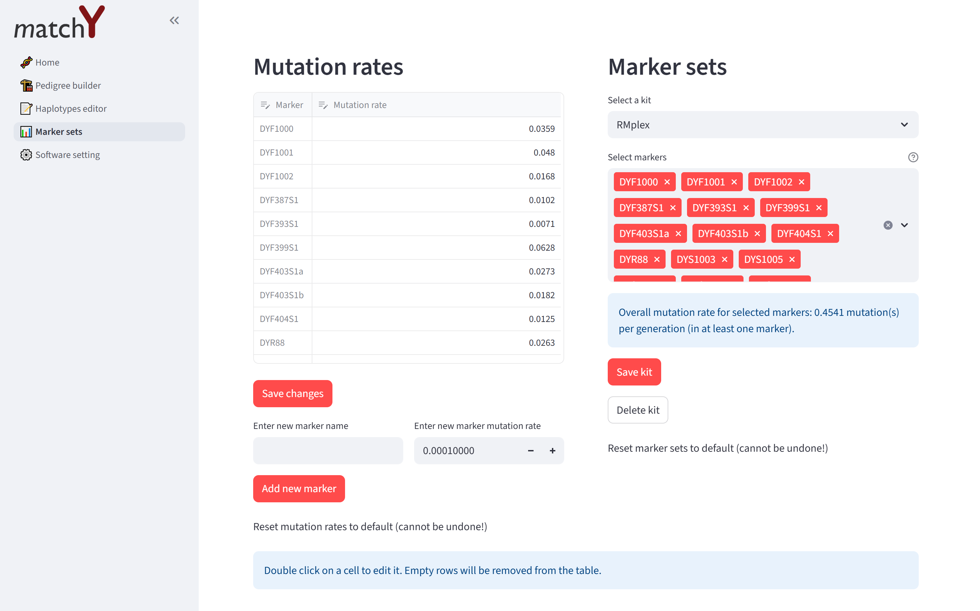
By default, the markers and mutation rate of RMplex, Yfiler Plus and PowerPlex Y23 are included. You can change the name or mutation rate of markers by double clicking on the value. Remember to click Save changes. Empty rows will be removed from the table. You can also enter new markers with their corresponding mutation rate. The new marker will be added at the bottom of the list of markers. When you click Reset mutation rates to default, all custom markers will be deleted.
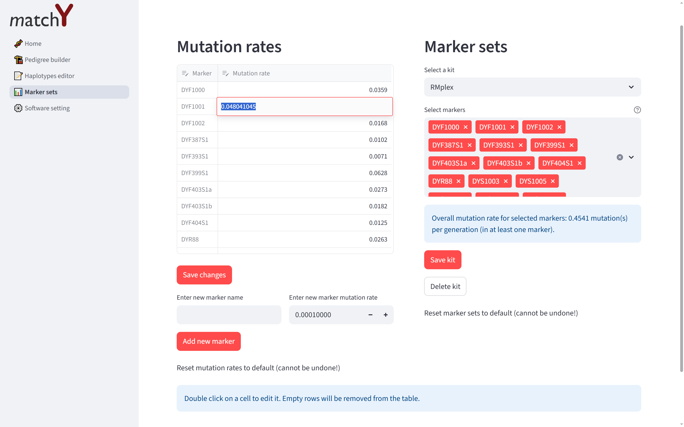
Next, you can change and add marker sets (i.e. marker kits). By default RMplex, Yfiler Plus and PowerPlex Y23 and the combined set are available. Markers can be added or removed from existing sets, or a new set can be created. To create a new set under Select a kit select Add new kit. Enter a name for the new kit and select the markers from the drop-down list. You can just start typing the marker name to easily filter the drop-down list. The overall mutation rate of the marker set is given: the probability that at least on of the markers in the marker set mutated in a father-son pair. When you click Reset marker sets to default all custom changes and additions will be removed!
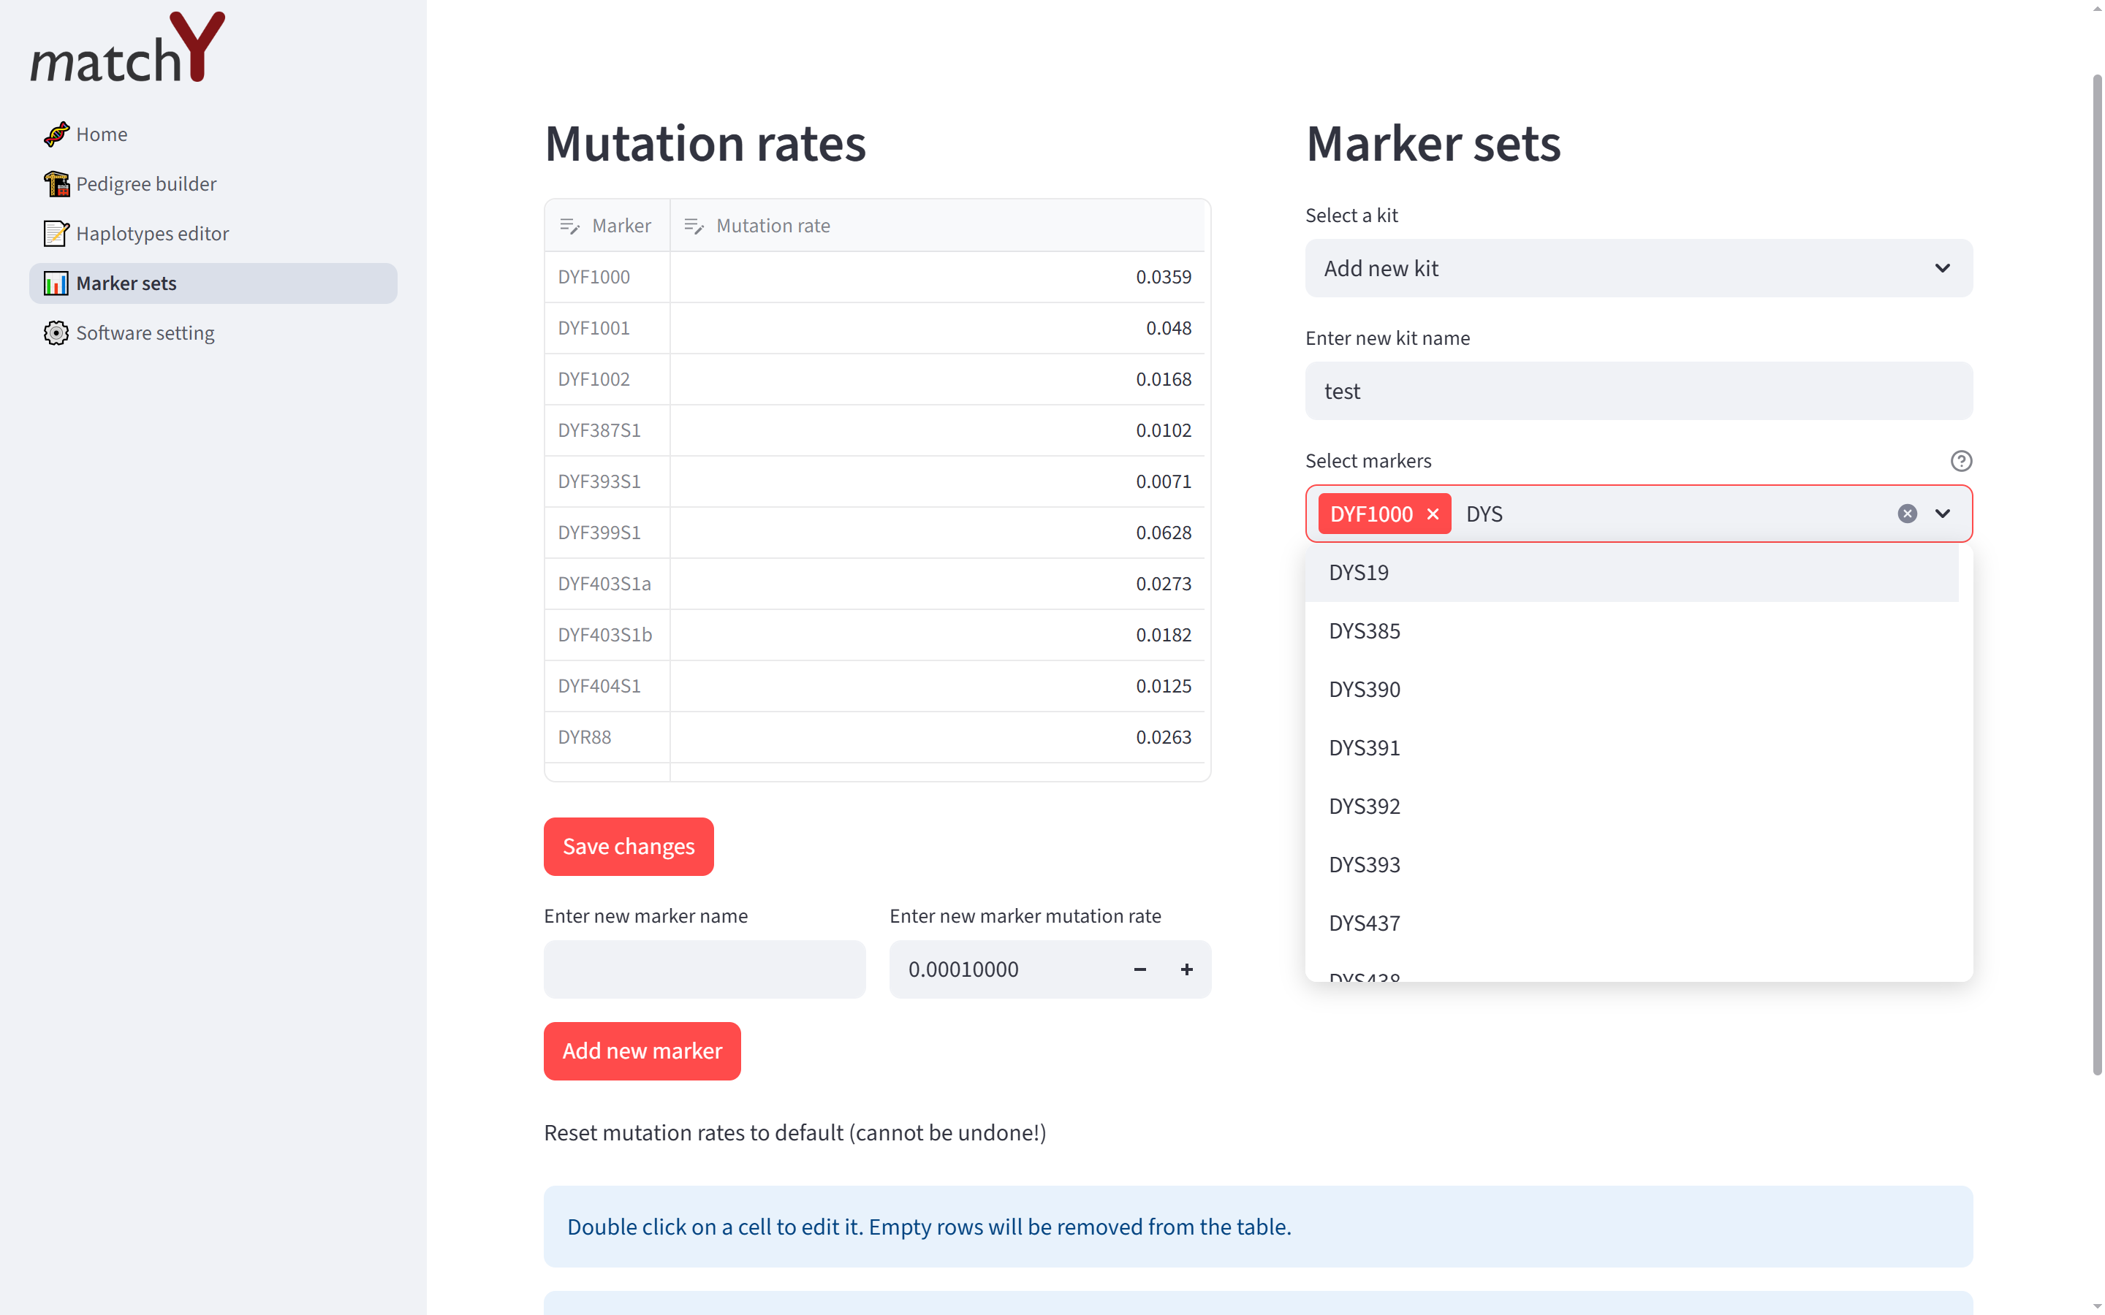

Create a pedigree
After you have set up the correct marker sets and mutation rates, you can start building your pedigree. Go to Pedigree builder in the menu. From the sidebar you can now start adding new individuals. Start with the oldest common ancestor and work your way down the pedigree. The reason for this is that for the next individual you add you will need to specify his father – so the father must already exist then.
After adding a new individual the selected father is automatically updated to the last added individual. Remember to each time select the correct father when adding a new individual. The name of each individual must be unique. If you want to remove an individual from the pedigree select that individual from the drop-down list and click Remove individual(s). Please note that all descendants of this individual will also be removed from the pedigree! Remember to download the pedigree if you want to use it for future references. If you click Download pedigree a TGF-file of the pedigree will be downloaded.
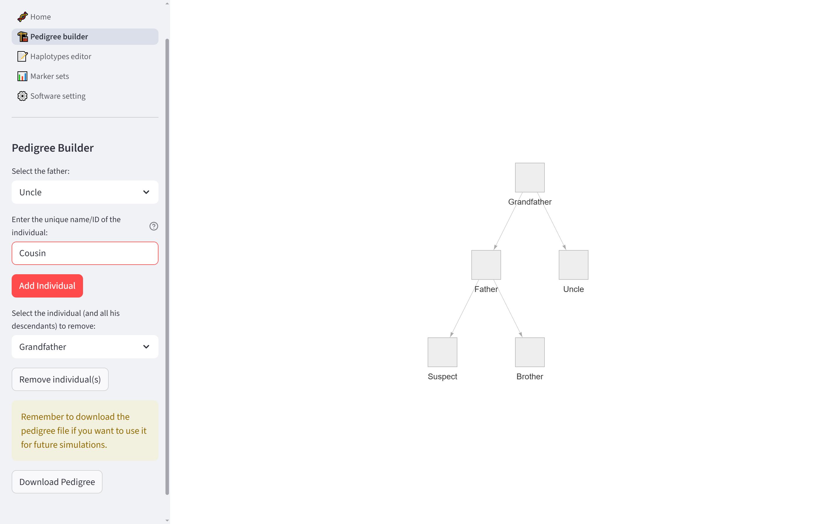

Setting the known haplotypes
After setting up your pedigree it is time to enter the haplotypes of known individuals. The simulation will require at least one known haplotype (that of the suspect), but any number of individuals in the pedigree can be given a known haplotype. Go to Haplotypes editor in the menu. Select the correct marker set from the drop-down list. A table is shown with all markers from the selected marker set. You can now add individuals from your pedigree to the table and enter their haplotypes. (Note that your can also use the Haplotype editor when you don’t have a pedigree loaded. This is not recommended, since the simulation will require strictly matching identifiers for individuals in the pedigree and the haplotypes file).
If you select an individual from the drop-down list you can either choose

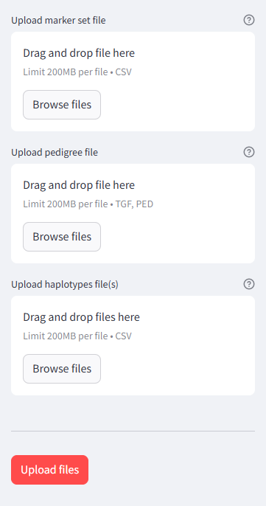
Setting up your calculation:
To run a calculation you will need three type of file:
- Marker set (containing the marker mutation rates)
- Pedigree file (containing the pedigree structure)
- At least one haplotype file (containing the haplotypes of all known individuals in your pedigree)

Tip: You can download an example file for all three file types.

The marker set file:
The marker set file should be a csv file containing two columns. The file should contain the following header:
marker,mutation_rate
The locus can have any alphanumerical value. The mutation rate should be a decimal value, with a point as decimal sign (i.e. 0.001).

The pedigree file:
The pedigree file should be in TGF or PED file format. You can use the free software yEd to easily create and edit pedigree files. You can also use matchY’s build-in pedigree builder (see pedigree builder).
Make sure that the individuals in the pedigree all have unique identifiers and that there are not cycles in the pedigree structure. The pedigree structure should be a directed acyclic graph (DAG). Also make sure that all individuals are connected to each other – there can be no loose individuals in the graph.
Individuals in the pedigree are colored based on the following classes:
- Red: suspect
- Green: individual with known haplotype
- Light grey: individual with unknown haplotype
- Dark grey: excluded unknown individual
- Dark green: excluded known individual

The haplotype files:
You have to upload at least one known haplotype file (that of the suspect) for the simulation to run. You can, however, upload more haplotype files for other known individuals in your pedigree.
A haplotype file should contain two columns. The file should contain the following header:
marker,alleles
All loci that are present in the haplotype files should also be present in the marker set file, so make sure the names are identical. The same loci need to be present in all known haplotype files – null alleles or dropouts cannot be used in this version of matchY.
Allele values should be numerical and can contain an intermediate value (i.e. 23.2). If a marker is a multi-copy marker, you can enter multiple alleles, separated by a semicolon (i.e. 23.2;25). If you enter more than one allele value for a marker, make sure that the same number of alleles is present in alle known haplotype files – different copy-numbers between multiple known haplotypes cannot be used in this version of matchY.
The filename should have the same identifier as the individual name in the pedigree. Make sure that the filename and unique identifier of the individual in the pedigree are identical.

Pedigree builder
To easily create a pedigree within matchY, you can use the pedigree builder. From the sidebar select “pedigree builder”.
Some notes on how to use the pedigree builder:
- Start building your pedigree with the most recent common ancestor (i.e. the root of your tree/pedigree). Since you will need to specify the father of each subsequent individual you are adding to the tree, it is necessary to start with the oldest generation and add younger generations later.
- Once you have added you first individuals, you can add new individuals by selecting the father and then adding the new individual.
- If you want to remove an individual be careful when to remove individuals that have sons – once you remove the father, the sons will become loose individuals. If you want to remove a father, you will first need to manually remove all sons.
- Download your pedigree and save it somewhere on your computer so you can use it later in the simulation.

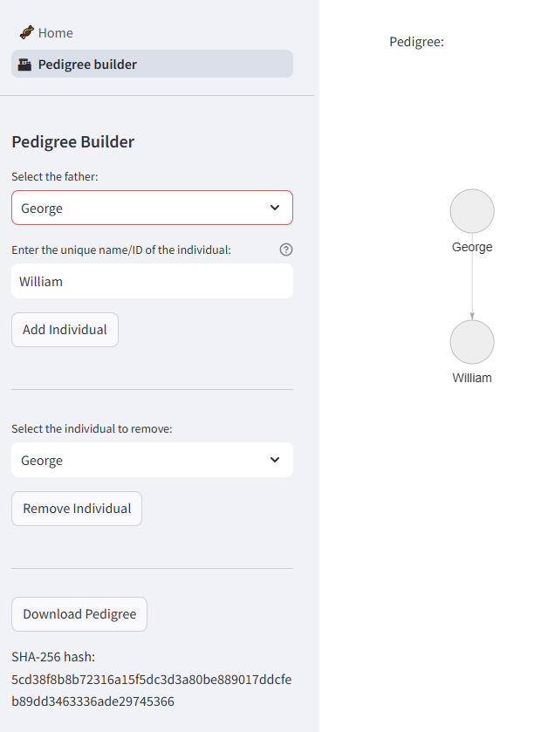

Setting up the simulation
After you have uploaded all necessary files, you can setup your simulation.
Click on Upload files.

Suspect:
First, you will need to specify your suspect. Enter the name of the suspect. The unique identifier of the suspect should be present in the pedigree and should have a known haplotype.

Excluded individuals:
You can exclude individuals from the calculation (for instance individuals that are excluded based on police intelligence). Enter the unique identifiers of individuals that need to be excluded. This can be either individuals with known or unknown haplotypes.

Set simulation parameters:

Number of iterations:
The number of iterations is the maximum number of iterations that the simulation is allowed to use. The simulation will, however, terminate earlier if the match probabilities are stabilizing. If the maximum number of iterations is reaches, a warning message will appear, indicating that the simulation might need more iterations to stabilize.

Random seed:
Random seed is used to reproduce the same results when running the simulation multiple times. When you run the simulation again with the same settings and the same random seed, the exact same results should appear.

Two-step mutation factor:
The two-step mutation factor is the factor by which the mutation rate is multiplied for two-step mutations. When this is set to 0, only single-step mutations are used in the simulation. If a two-step mutation is encountered in the pedigree (based on known haplotypes), the pedigree is considered impossible. For now, only two-step mutations are possible, multi-step mutations are not yet possible in this version of matchY.

Stability window:
The simulation will terminate earlier than the specified max number of iterations when the results stabilize over time. The stability window is the number of iterations the result need to be stable before terminating the simulation. When the model is invalid, it is likely that the simulation has reached a local optimum, and it is advised to increase the stability window.

Stability threshold:
The stability threshold is the maximum allowed relative change between consecutive probabilities. When the model is invalid, it is advised to decrease the stability threshold.

Stability minimum iteration:
The minimum number of iterations that the simulation has to run before checking if the results are stabilizing.

Model validity:
The simulation is being run three consecutive times. The model validity threshold is the maximum allowed relative difference between the model results for the model to be considered valid.
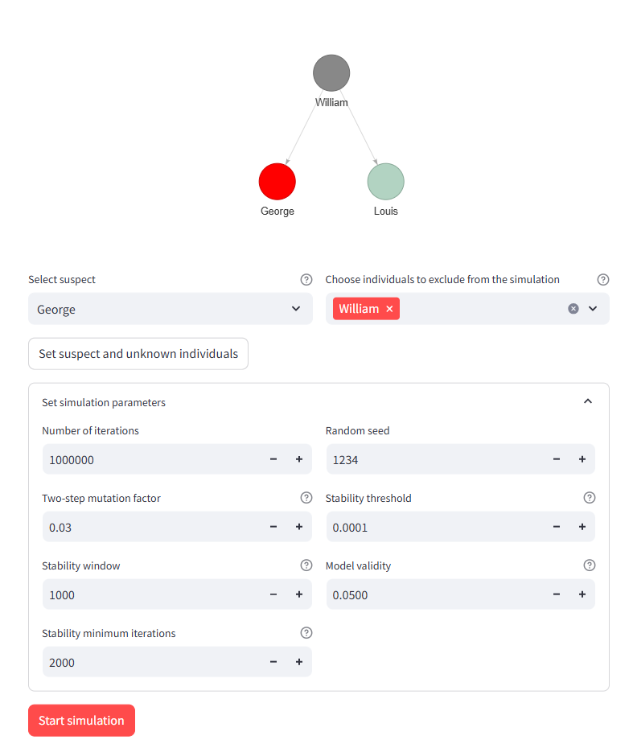

Click on Start simulation.
You will see a progress bar indicating the progress of the different simulation steps. After the simulation is done, you will find a table listing the match probabilities for each number of matches.
You can download a report with all the result by clicking Download results as report.

